How to Stop your Cat from Attacking You or "Kill the Bear"

When your cat suddenly pounces on your feet, pant legs or hands, wrestling and biting at you, they are looking for an outlet for predatory play. They are not truly meaning to hurt you or another pet. This is normal necessary play behavior for cats. Some cats are more into this than other cats. All kittens go through this "attack" phase and some will keep it up as adults.

What to do? Squirting them with water, throwing things at them, yelling at them, or hitting them will not make these attacks stop. They will often avoid you and may become more aggressive out of fear of getting hit, squirted with water, etc.
So give them an outlet for this normal needed behavior. This is when it is good for your cat to "kill" a stuffed toy like a teddy bear. The cats will focus attacking on the stuffed toy, not you or the other pets. This is far better than getting another cat to be attacked. You may see cat to cat behavior problems if you just get another cat.

- Get a stuffed animal like a teddy bear, or bunny rabbit about the size of an adult cat. A cast off one from a child is fine. It has to be this big to allow your cat to grab it with front and back legs, bite on the head and wrestle with it. If it is too small the cat can not do all the needed actions of predation(grabbing, biting, treading) and will still need a place to do this which maybe you!
- Keep this toy up on a shelf and bring it out maybe once a day. This keeps it fresh for the kill.
- Throw the toy low like skipping a pebble on a pond.This motion is what gets the cat's attention to pounce, then attack.
- Leave your cat alone while they start to mouth or attack the toy. If you shake the stuffed toy with your hand the cat will likely grab your hand too and we do not want to link biting you or your had with this play.
- When they stop and leave the toy, throw it again and restart the play. Keep doing this until your cat is tired. This may be for a few throws or maybe 10 throws but your cat has to feel that they have let out all their need for "killing" on this toy. If play stops too soon, they will keep going after you or another pet.
- If your cat gets really excited about grabbing the toy as you reach to get the toy, you can use long kitchen tongs to grab the toy, or tie a fat ribbon about 4 feet long to pull the toy away to you to throw it again.
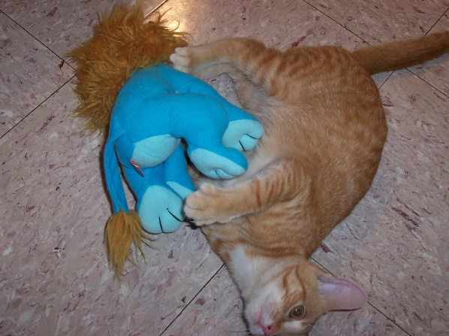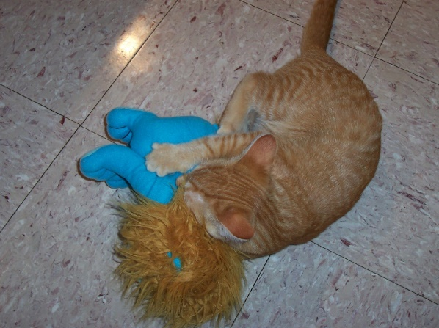
Wrestling with the Lion - Normal happy attack "Killing the Lion" - Finished with
predation - Happy cat

- written by Dr. Sally J. Foote

