Fear of Fireworks

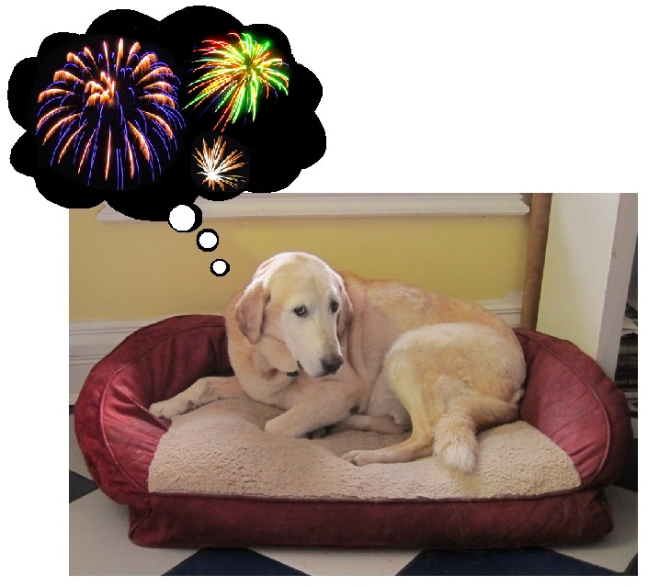
Many dogs are afraid of fireworks. Maybe a dog was left alone during a fireworks and did not know where to go or what to do. It may be genetic, or it may be something that has been increasing over the years. Whatever the cause, firework phobia is very common and can range from mild to severe. There is help for your dog. Help is in the form of a plan to teach them to be calm with the help of antianxiety medication as determined by your veterinarian.

When your pet is young do train them to be rewarded for calm, non-anxious behavior during fireworks, and other loud noises. Teach them to go to a "safe" spot in the house. Their safe spot may be their bed, your bed room or a bathroom. Command them to the area before the fireworks start and reward them. Give them a bed, crate or in the bath tub to lie on and reward them for going there fast and lying calmly. You can give them a rawhide or Kong filled with treats to chew and lick at while the fireworks explode overhead. Heavy beat rock music or Egyptian/Indian music is very helpful also. See Butterscotch's play list for suggested songs that have helped many dogs. Adaptil collars are also helpful to reduce fear.

For the dogs that are pacing, panting, drooling, circling, howling, pawing at their owners, climbing on to furniture, hiding under the bed, in the closet, digging out of doors or windows there is help for them. There are different levels of fear, and each level causes some physical pain. The dog may not be completely fearless during fireworks, but they can be more calm, which is much better for them.

Proper antianxiety medication (not just tranquilizers) during fireworks are very effective. These medications are not sedatives, although sedatives may be part of combination treatment in severe cases. Your dog will not be constantly drugged out. A check up and blood check are needed before starting treatment.

A plan to help your pet have a better 4th of July season is possible with the help of a veterinarian and staff offering behavioral help. Helping your dog will also help you. Read Dr. Foote's blog (https://drsallyjfoote.blogspot.com/) for more help.

- written by Dr. Sally J. Foote

