Potty Primer for Puppies

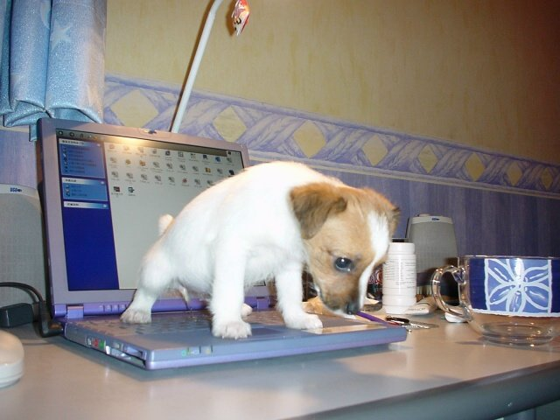
Getting a puppy to learn to use the bathroom outside or on a special place in the house can be a little challenging, and for some puppies it seems impossible. There is good information from the major pet food companies on how to train a puppy to go outside. Often on your first veterinary visit you will get a kit with a puppy care book that has these instructions in it. If you missed that, ask your veterinarian for a puppy kit.
Here are the most important factors to potty train your puppy:

1. Feed only meals. Do not leave the food out. Two times a day, food down for 20 minutes maximum will result in the puppy having a bowel movement in about 10-30 minutes. So scheduled feedings leads to scheduled poops. If you puppy is not eating well, be sure that your pup has been wormed and is on a high quality major brand food. Cheap food equals lots of stools.

2. Water is a drink. Offer about 1/4 to 1/2 cup of water every 2-3 hours. Some puppies just love to drink so they will drink a lot and then you know what a lot leading to accidents in the house. Ice cubes are okay if they seem thirsty a lot.

3. Use a leash, go out the same door to the same spot every time. The puppy sees the leash and learns that this is potty time. Off the leash after the first week the pup gets distracted and does not finish all the business. With you on the end of the leash you praise as the puppy is going. Do not wait until you are in the house - otherwise the puppy thinks they are good to come in and will not finish up outside.

4. When the puppy is awake, take them out every hour. Set the kitchen timer for an hour right after you come in. They need to go more often when active and the repetition of all the steps to going outside is what teaches the puppy overtime to go to the door, or come to you and bark to go out.

5. Do not punish your pup for accidents in the house. They don't understand, they cannot help it and it creates a lot of fear and anxiety problems later. If the pup has had an accident, clean it up and take the pup out. What did you miss? Get busy and not take the pup out as soon as they started to pace or whine? Puppies have a literal 5 second warning for you so follow the prompt no matter how cold and get them out!

6. Avoid problems by using a crate positively and baby gates to keep the pup in the room you are in. When a pup is out of sight, how can you know they need to go? If a puppy passes stool or urine on a surface 4 times or more they think that is a toilet even if it is your oriental carpet or hardwood floor.

House training is the first thing a puppy needs to learn well. There are a number of steps and it does take time. As is often said, sometimes it is training the human to be consistent and observant to the puppy. Good luck with your new friend.

- written by Dr. Sally J. Foote

