Tornado / Storm Safety Drills for Pets

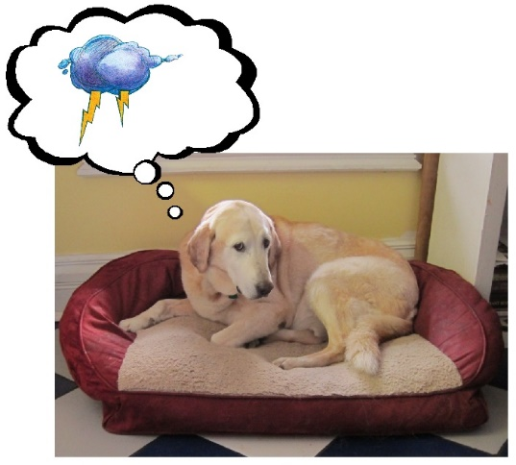
I recently presented a thunderstorm phobia - storm safety plan talk in my community of Tuscola. Our town was lucky to escape the touchdown of tornadoes that passed through central Illinois last November. A few homes in rural Tuscola were badly damaged, and I thought about this as April approached. I wondered how many pet owners have trained their dogs and cats to quickly come to the basement, bathroom or into their crate when a storm is approaching? My staff and I began to ask clients on every exam how well their pets would go to a safe place. The results varied with many clients admitting to not having a plan. I made it a point at my presentation to include how to train one's pet to go to a safe place no matter how calm the pet was during storms or afraid. Here is the information for you:

Storm safety plan for dogs:

First, set up your storm safe area for your pets to be comfortable in. If it is your basement, put a blanket or place for them to lay. Some dogs like to lay on the concrete or tile. There is some theory that this may be grounding the pet to reduce the electrical charges in the air that they sense. If your dog like the concrete then don't worry about a blanket.

Second, hang a leash near the basement safe room. Use the leash for fun things like a walk, or going to the park so your dog will like the leash. A 6 foot leash, not a flexi type is best. Using the leash will help your dog to know where you want them to go, quickly and you will also have a hold of them to prevent escape.

If you have multiple dogs, have a place you can tie up the leash in the safe room as you can gather up the other dogs. This will prevent one from getting out as you get all your pets in. A grab bar meant for showers can be installed low on the wall to tether them.

Here is the drill: Do not feed them dinner out of the bowl. Put the food nuggets in your pocket and call your dog to you. Give them a few nuggets for coming. Walk towards the leash and give them food as you walk to the leash, attach the leash and go to the basement/bathroom door. Reward as you open the door, every few steps into the bathroom/basement area. The key is to keep the dog focused on the reward every few steps. Toss kibble into the tub to get your dog to jump in. Step into the tub yourself with your dog and lots of reward here. You may need to be in the tub with your pets during a bad storm so get them used to the huddle. If you can have a cd player that plays heavy rock music in your safe room to calm your pets. Avoid radios that will sound alarms which may startle your pet. Repeat this drill every few days so it is fun and automatic. Then when the big storm comes you will have a plan that your pet knows and everyone will be a lot calmer and safer.

Storm safety plan for cats - train them to go to their carriers easily then you can take the carrier to your safe room. If you have to leave them in the carrier, this is the safest place for them.

Cats don't like their carriers because they are only used to go to the veterinarian. The goal is to get your cat to love running into the carrier.

First, keep your carrier out at all times. Make it a part of the family room furniture. Put a favorite blanket in it. Do not put your cat's food out for a day. Take the food nuggets and toss them on the floor around the carrier. Make it a game by tossing just one nugget at a time around and then into the carrier. This is a great way to play with your cat. If the dry food is not enticing enough, then try small bits of tuna or other tasty treat tossed into the crate.

When your cat will run right into the carrier for a nugget tossed in, close the door without latching it. Just close the door and then allow the cat to come out after eating. When the cat is eating the food with the door closed, then go to latching it. Keep practicing calling your cat - tossing nuggets into the crate and latching the crate door as your cat is calm in the crate. Now you can put the crate in the bathroom, take it to the basement or leave it in a windowless area.

You can see demonstrations of these plans on my youtube channel:
https://www.youtube.com/user/DrSallyJFoote#

If your dog or cat is nervous on the storm days, there are non-sedating medications available to calm your pet. If your pet is too nervous to take a reward, they need anti-anxiety medication or supplement to help them. Adaptil pheromone collars help many dogs, lasting 30 days without any side effects. Supplements such as Zylkene, the milk calming supplement or the Anxitane can also help. The right product for your pet determined by your veterinarian knowledgeable in behavior, will help your pet be calmer.

- written by Dr. Sally J. Foote

