Play with your Food? It's Good for Body and Brain
For many animals eating is not just about hunger. There is a lot of activity around searching for, finding and then eating a food in the wild. Our pets are not wild animals, yet the need for finding a food and then taking it apart to eat it is still ingrained in the brains of our dogs and cats. Toys that have food kibble spill out of them when batted around, or pulled apart help the pet to have more physical and mental activity. This helps to keep them happy and actually eat less preventing obesity problems. These food puzzles/toys also help treat and prevent many behavior problems.
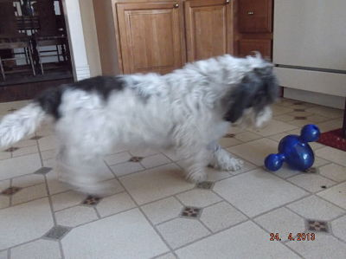
Dogs in particular like to chew on things as a young dog as a way of investigating what something is. As the pup grows up, this desire to chew may decrease or be the same. Some dogs like to unstuff things rather than actually chew and devour. All of these actions are a part of the hunt and kill pattern that dogs would do in the wild. Even our pet dogs still have this desire in them which is part of why they like to chew on toys and other things. See what your dog likes to do most: unstuff toys, or chew on things like rawhide, sticks, table legs, books, etc.? Pick a food toy that matches what they like to do. If your dog likes to unstuff things, then a Kong toy with the food packed in and frozen helps them put that behavior on something good, saving your sofa. For dogs that like to chew, hard rubber food toys such as the linkables require them to chew and mash the toy to get the food out, again saving destruction. All of the food toys require the dog to figure out how to get the food out, which is a great way to relieve boredom and stimulate their brain. Food toys help dogs with cognitive dysfunction syndrome (doggie senility) and can slow down its progression. Often times giving a food puzzle as you leave distracts your dog, decreasing separation anxiety problems. Your dog also gets more exercise and will eat less food since it takes longer to eat when you use a food puzzle. This can help with weight management.
Cats also can like their food toys. Cats really need life to be more exciting and challenging. They really like to hunt out their food. So, hide food in empty Kleenex boxes with the plastic flap in place. Cats have to paw, and flip the box around to get the food out. There are balls that the cat can knock around to release food also. Empty water bottles can have food kibble put in them for the cat to grab, kick around and knock the food out of. Using food toys is an excellent way to get cats to exercise more, and control how much they eat. This is one of the best ways to get cats to lose weight. Many cats are overweight, and that excess weight can lead to diabetes, joint problems and urinary problems.
Much of this information about how animals like to hunt and work for their food comes from observing animals in the zoo. When you go past the gorilla exhibits, you will likely notice the bananas, apples and other food scattered all over. The apes are not messy. Hunting and finding food is what the apes like to do, it keeps them from being bored and much healthier. The same is basically true for our pets.
Sometimes people feel it is mean or unfair to put the food in a puzzle that the animal has to figure out in order to eat. Actually, our pets really like to have challenges. Food puzzles are a great way to give out pets an outlet for exercise, mental activity and fun.
- written by Dr. Sally J. Foote
Food puzzles and where to find a bit of information about the puzzles and how to purchase them:

Buster Dog Maze by Kruse
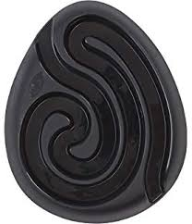

Kong, Wobbler, Genius and others made by Kong
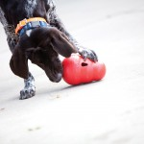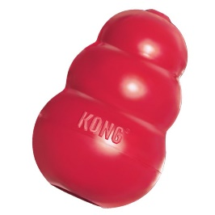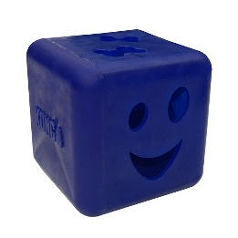

Kibble Nibble, Twist n Treat, Linkables and others made by PetSafe
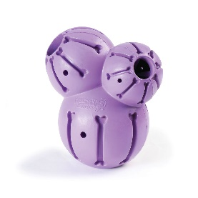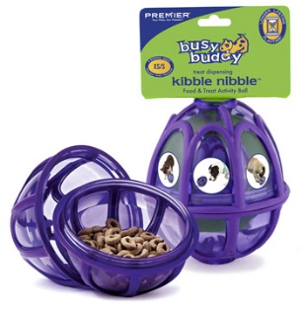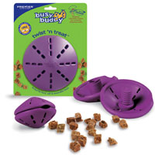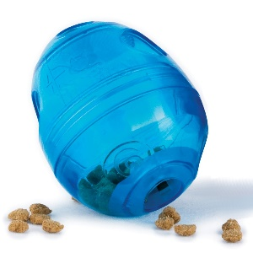

Tornado, Casino, Dogsmart, Spinny and others made by Nina Ottosson
