Top 7 Things to do for Storm Settling and Safety

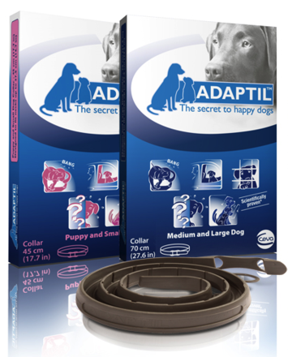
- When it is not stormy out, toss treats and occasionally feed your dog in the basement, bathroom or other safe room for a storm. This makes it fun not scary to go in there before and during a storm.
- Put rap, Latin dance, disco or rock music from the 60's to the 80's with a regular danceable beat heavy in the base. No high pitched singers or guitars. No TV. Find the oldies station and play only that one. The beat is what keeps your pet's heart rate at a slower pace to keep them calm.
- Stuff a Kong toy with canned food and keep in the freezer. When the first winds pick up, toss this in the safe room to keep your dog distracted and rewarded for being calm.
- Try a tight fitting T shirt or a Thunder shirt ™ when the first signs of a storm appears. Keep the shirt on them until after the storm has passed.
- Use Adaptil collars or spray on a bandana on storm days. Keep the bandana refreshed with spray 2-3 times a day. Use this early, at the first signs of storms.
- Ask your veterinarian about non tranquilizer - anxiety reducing medications and supplements that help dogs be less fearful. There are different combinations of medications that can help severely affected pets that do not drug them up. Alprazolam - Reconcile - Clomicalm - Theonine are a few.
- Stay calm yourself, do not scold your pet or put them in a crate that they hate. Allow the pet to go where they are most calm even if it is under the bed.
Always have your dog or cat wear an Identification tag and have your pet micro chipped. In severe storms pets can escape from the home and without identification how will they get back home to you?
For more Storm help download Butterscotch's Playlist and read "Thunderstorm Nightmares No More" on Dr. Foote's blog.
https://drsallyjfoote.blogspot.com/2011/04/thunderstorm-nightmares-no-more.html

Now Butterscotch is happy and calm during storms
- written by Dr. Sally J. Foote

